REGISTER TODAY. DON’T DELAY!
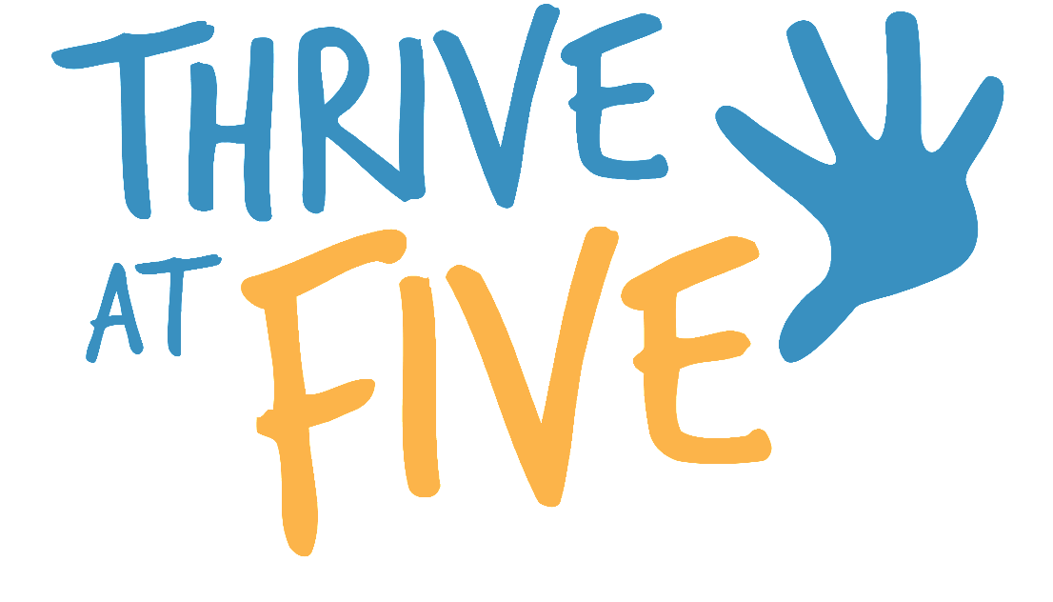
Kindergarten Registration is open
from January 17 until May 31, 2023.

*Other Languages will be added soon*

Albanian / Shqiptare | Khmer / ខ្មែ
Arabic / عربي | Portuguese / Português
Chinese / 中国人 | Russian / Pусский
English | Spanish / Español
French / Français | Vietnamese / Tiếng Việt

